Budget Update

Purpose of report
For direction.

Summary
The Budget contained a suite of announcements pertinent to the government’s levelling up agenda. Four areas believed to be of particular interest to members of the People and Places Board are set out below: funding for growth; local enterprise partnerships; the plan for growth; and, jobs and skills. Members are asked to consider each of these issues in turn and help steer the LGA’s future work.
Recommendations
Members of the People and Places Board are asked to:
  - Note the announcements relating to three new investment programmes and consider how best to approach the issues raised by councils, particularly those relating to the levelling up fund.
  - Note the launch of a fresh review of local enterprise partnerships and agree to further engagement on this issue
  - Note that the Industrial Strategy has been superseded by the Plan for Growth.
  - Note the announcements related to skills and employment and agree to write to the Employment Minister to discuss Kickstart and seek an introductory meeting on skills with Gillian Keegan MP, the relevant Minister
Action
Officers to take forward work subject to the comments of members.

Contact officer: Philip Clifford
Position: Senior Adviser
Phone no: 07909 898327
Email: philip.clifford@local.gov.uk

Budget
Background
- The Budget contained a suite of announcements pertinent to the government’s levelling up agenda. Four areas believed to be of particular interest to members of the People and Places Board are set out below: funding for growth; local enterprise partnerships; the plan for growth; and, jobs and skills.
Issues
Funding for Growth
- The budget saw the launch of three new investment programmes:

  - The UK Community Renewal Fund - £220m to pilot new approaches to skills, business support and employment ahead of the launch of the UK Shared Prosperity Fund in 2022. Funding will be allocated competitively. The government has identified 100 priority places based on an index of economic resilience to receive capacity funding to help them co-ordinate their applications.

  - The Levelling Up Fund - £4.8 billion which will seek to invest in infrastructure that ‘improves everyday life across the UK’, including town centre and high street regeneration, local transport projects, and cultural and heritage assets. The fund’s announcement included a list of local authorities categorised into three priorities. Preference will be given to bids from higher priority areas and capacity funding of £125,000 will be available to local authorities ‘most in need of levelling up’.

  - The Community Ownership Fund - £150m to help ensure that communities across the UK can continue to benefit from the local facilities and amenities that are most important to them. From the summer, community groups will be able to bid for up to £250,000 matched funding to help them to buy local assets to run as community-owned businesses. The first bidding round for the Community Ownership Fund will open by June 2021. A full bidding prospectus will be published alongside this.

- While the LGA welcomes the leading role for councils in these funds our on-the-day briefing highlighted a number of initial concerns: the prospect of competitive bidding at a time when councils are stretched by the need to protect communities and businesses from the pandemic; the scale of these funds when set against the challenge of recovery; and the potentially fragmented and complex bidding process, particularly for the levelling up fund, that sees different tiers of local government able to submit bids for different purposes and an important, but uncertain role for MPs in the bid selection process.

- Since the budget councils have called for further clarity around the funds. Much of this has centred on the methodology underpinning the prioritisation of areas able to bid for the levelling up fund, which has implications both for the likely success of any bids and the allocation of capacity funding to support the bidding process.

- The prospectus attached to the fund indicated that an area’s priority has been determined by an index considering the following characteristics: need for economic recovery and growth; need for improved transport connectivity; and need for regeneration.
For reference a map providing an overview of the three priority areas is set out below:

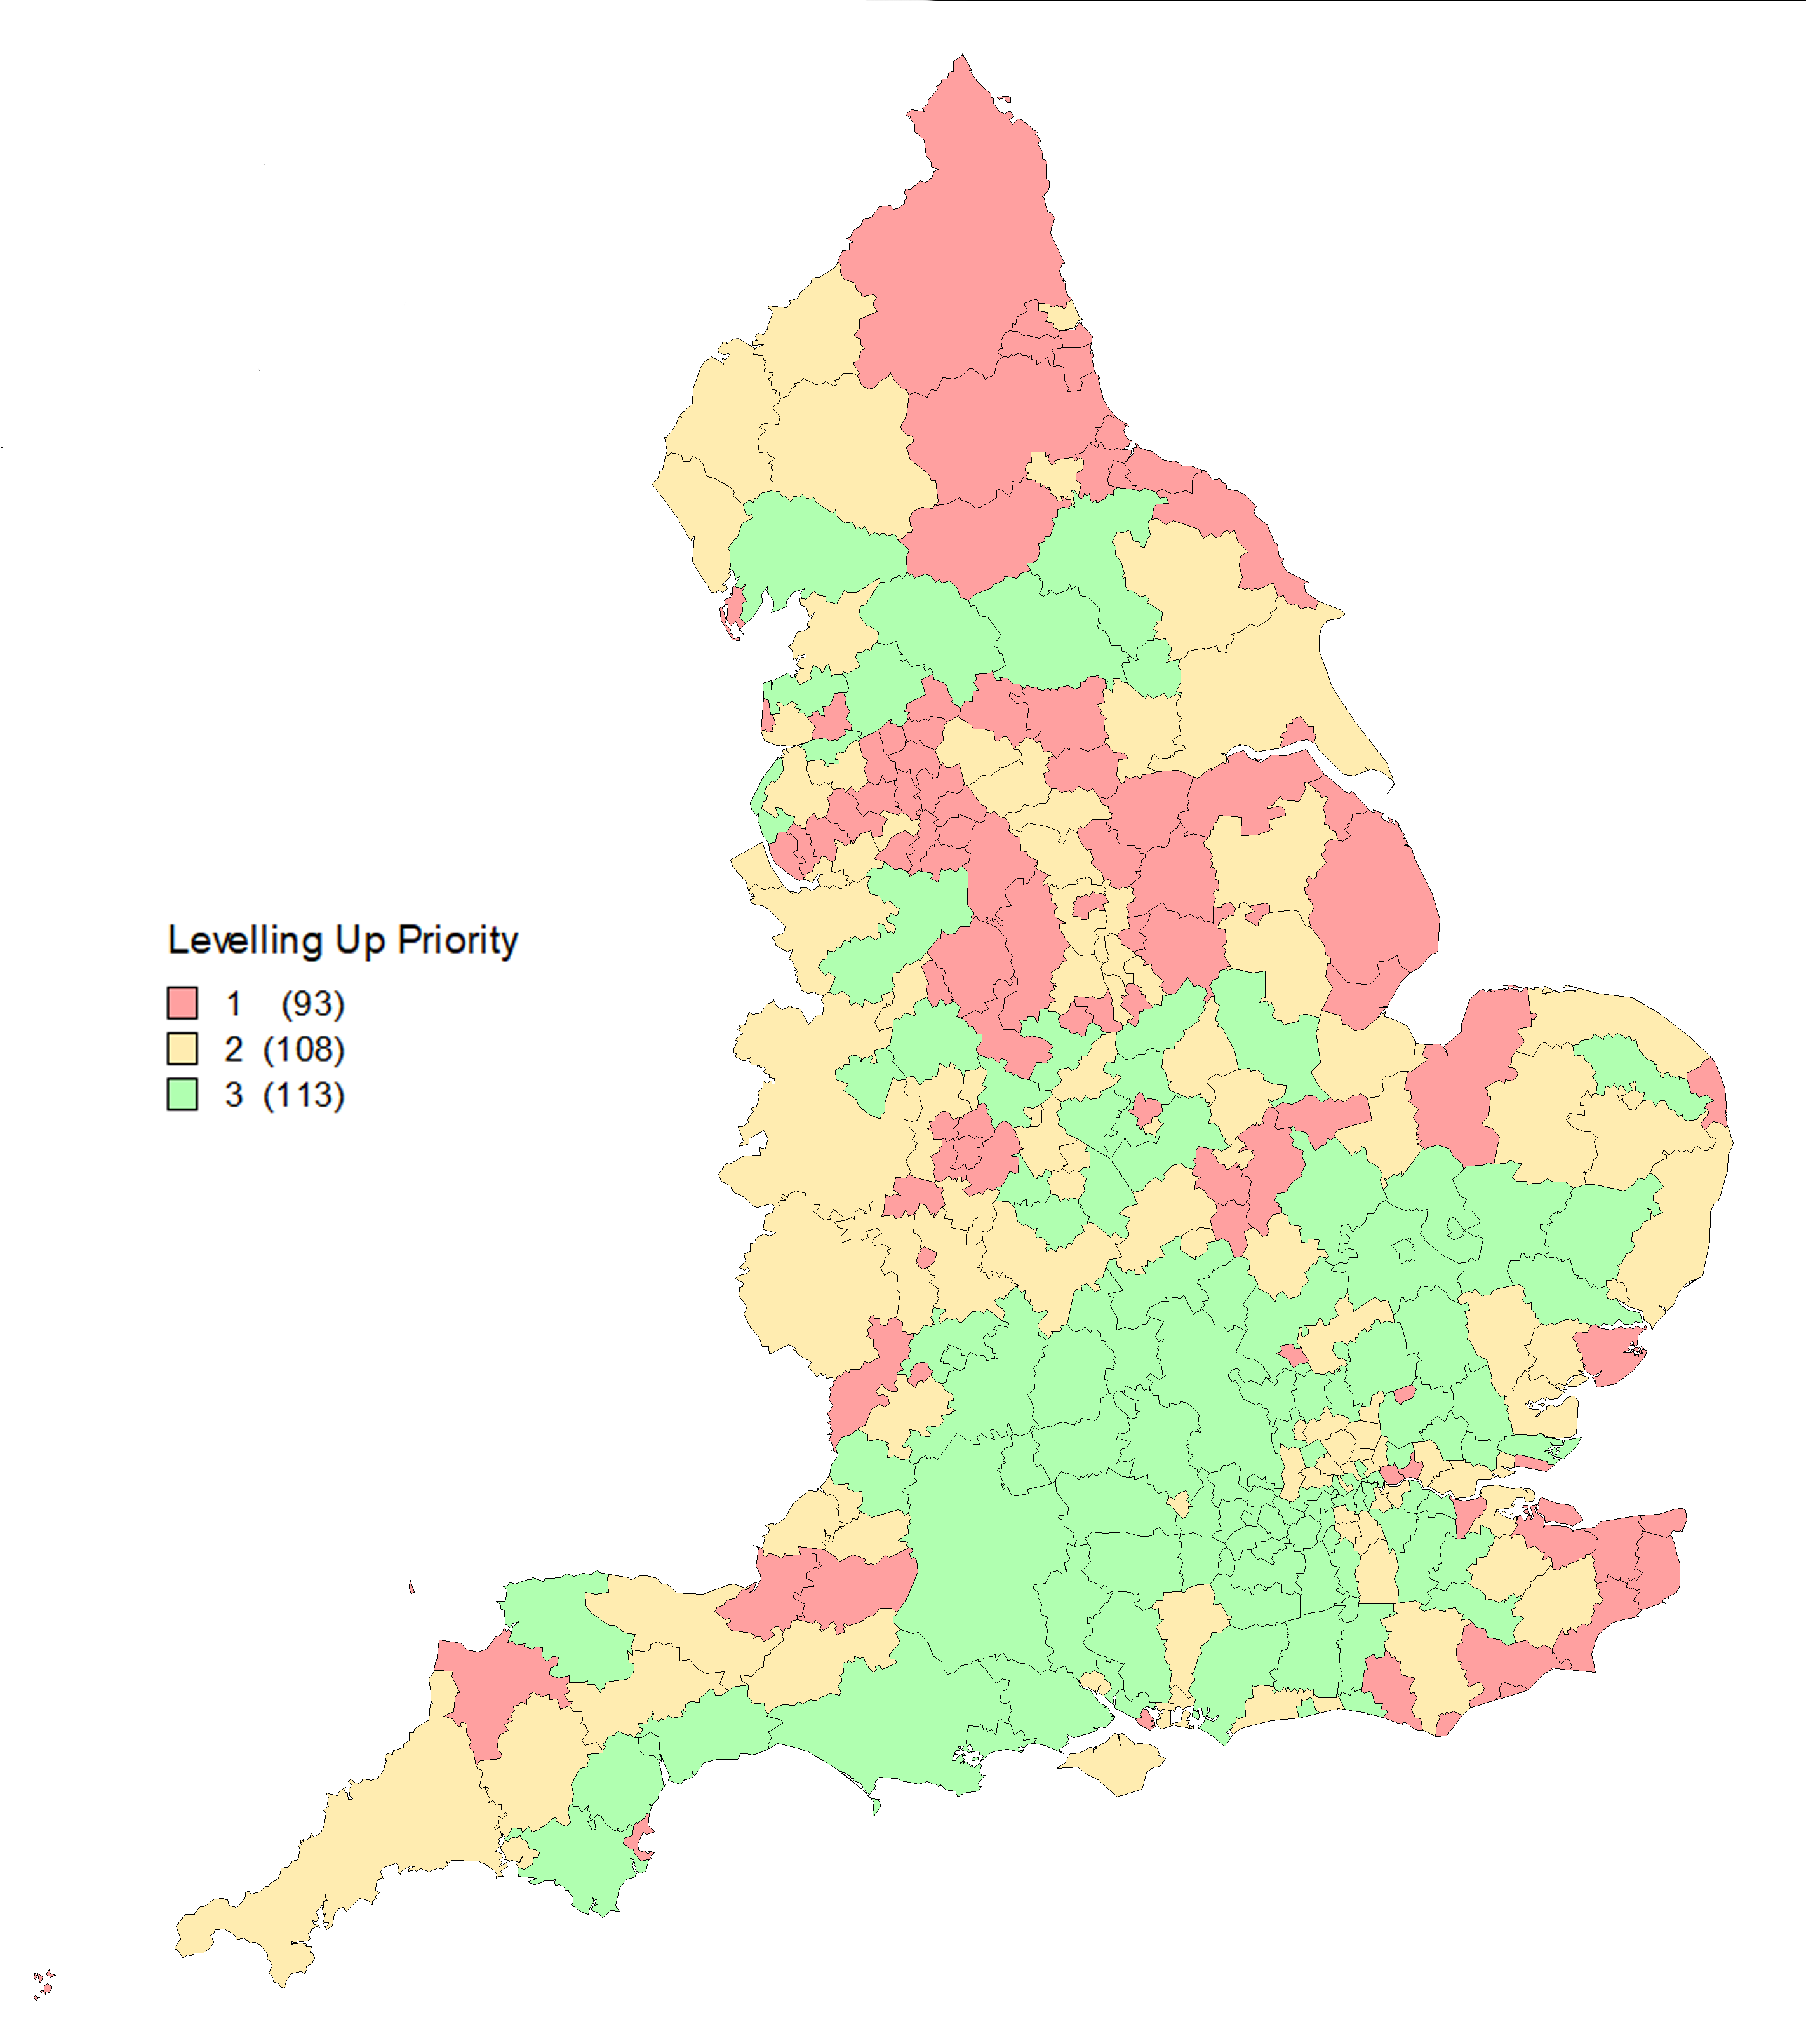
- The requirement for competitive bids places additional emphasis on the allocation of capacity funding.

- Independent research by Localis for the LGA has identified a range of issues associated with frameworks for growth-related funding reliant on competitive bidding. The research looked at four funds and identified the following costs:

Fund | Total bidding cost (average) | Largest recorded cost
Regional Growth Fund | £17,500 | £50,000
Local Sustainable Transport Fund | £32,500 | £50,000
Local Pinch Point Fund | £34,000 | £68,000
European Regional Development and Social Fund | £20,000 | £30,000

- Officials have been keen to stress that the £125,000 capacity funding available for future years of the programme will help mitigate these concerns. However, given the methodological questions highlighted above there is a risk that those areas most in need of ‘levelling up’ are least likely to be able to effectively engage in a bidding process and therefore all the more reliant on an alignment between the prioritisation index and the availability of local capacity.

- More widely, concern has been raised that the funds go against the grain of devolution and risk being driven by Ministerial rather than local priorities. There has also been a significant degree of discussion regarding the metrics used to measure progress towards ‘levelling-up’ and a concern that by launching multiple programmes with similar timescales the Government risks many of issues highlighted by LGA published research into fragmented funding.

- Finally, questions have been raised regarding the role of local MPs’ ability to back a single bid within their constituency boundary. While the prospectus makes clear that MPs do not have a veto there are clearly concerns about how these discussion will play out in practice particularly in areas where an MP’s constituency crosses into multiple council areas or where local politics means consensus is more difficult to broker.

- The LGA, working with and alongside councils, has placed these concerns on the record with government. The Government has now published a Levelling Up Fund: Prioritisation of places methodology note. This provides more detail on the index used to prioritise places for investment and future capacity support. In summary, it identifies three composite measurements: need for economic recovery and growth, which incorporates productivity, unemployment and skills data; need for improved transport connectivity, which uses average journey time to an employment centre by car, public transport and bike; and, need for regeneration, which uses commercial and dwelling vacancy rates.

- In addition to this, the methodology for the UK Community Renewal Fund (UKCRF) has also been published. The UKCRF will be piloting schemes in advance of the launch of the UKSPF in 2022, but the design, eligibility and duration of the fund will be different to the UKSPF. Funding will be allocated competitively with lead authorities receiving capacity funding to help them co-ordinate their applications. The government has identified 100 priority places using a methodology based on economic performance and ability to resist and recover from shocks. They have developed metrics using a criteria based on: productivity; skills; unemployment rate; population density; and household income. The full details of the metrics and weighting used can be found online. We understand that the guidance for lead authorities will be published very soon. week.

- Throughout these discussions Government officials have been keen to stress the distinct priorities attached to each of these funds and site them within the overall package of support for the economy set out in the budget and elsewhere e.g. the national infrastructure strategy.

- It is therefore important not to lose sight of the intended purpose, context and scale of these funds. The role for councils is to be welcomed and the Community Renewal Fund provides an opportunity to influence the more significant UK Shared Prosperity Fund. It is also important to be clear that the priority of the LGA is, above all, to make the national case for increased local investment rather than seek to influence the distribution of any such funding.

- However, given the concerns expressed by many councils across the country and the questions of methodological transparency, the People and Places Board are asked to offer their thoughts on how best to take forward these issues with Government, particularly in the context of the Board’s wider work to strengthen the resilience of rural and coastal areas.
Local Enterprise Partnerships
- Alongside the budget MHCLG announced that they will be working with local businesses over the coming months on the future role of Local Enterprise Partnerships with a view to announcing more detailed plans ahead of the summer recess. This will also include consideration of Local Enterprise Partnership geographies.

- In 2017 the LGA submitted evidence to the LEP Review and supported a vice-chair of the People and Places Board as a member of the Review Panel. This contained several recommendations and led to a significant role for LEPs in the development of Local Industrial Strategies.

- Members of the People and Places Board have previously made the case that democratic accountability is crucial in the allocation of public funds. The key leadership role for councils in the growth funds identified above speaks directly to this concern and will no doubt be welcomed. However, LEPs provide an important role in bringing councils and local businesses together and within the context of a national economic recovery it would seem prudent to ensure that no capacity or expertise or expertise is lost through the process of review.

- It is therefore proposed that the LGA seeks to work with the LEP Network and Government to ensure that those aspects of partnership which work well are preserved.
‘Build Back Better’ The Government’s Plan for Growth
- A publication – Build Back Better: Our Plan for Growth – was also launched alongside the budget. This sets out the government’s plans to support economic growth through investment in infrastructure, skills and innovation. It identifies three key priorities: level up the whole of the UK; support the transition to Net Zero; and, support the Government’s vision for Global Britain. It also identifies a wide range of long-term strategies, including: an export strategy; the devolution and local recovery white paper; the transport decarbonisation plan; the net zero strategy; the national bus strategy; and, the full conclusion of the post-18 review of education and funding.

- In a subsequent Parliamentary exchange the Secretary of State of Business, Energy and Industrial Strategy announced that the Industrial Strategy [was] ‘morphing and changing into the plan for growth’. It has since been reported that the Industrial Strategy Council is being disbanded. Given the long absence of any Ministerial mention of local industrial strategies, it might also be reasonably assumed that these are no longer a national priority.

- The LGA will of course continue to work with councils and government on future strategies and proposals relating to place-based growth. It is hoped that the significant investment by councils and LEPs in the development of local industrial strategies will provide a robust evidence base for future economic interventions. As part of the Board’s ongoing responsibility to represent non-metropolitan England we will also continue to make the case for a coherent and place-based national strategy for recovery and growth.
Jobs and skills

- The Chancellor used the Spring Budget to announce an extension to furlough, further measures to encourage employers to take on more apprentices, funding to increase the number of traineeships, and measures to move towards a net zero economy.

- It was widely anticipated that there would be an extension to the Kickstart scheme, and we had hoped that National Skills Fund monies would be released to help upskill more adults to Level 2. Both of these are vital but neither materialised.

Kickstart for young people

- Local government has got right behind Kickstart as a means of creating much-needed local opportunities for young people hard hit by the pandemic, both within their council / combined authority and working with local employers to create opportunities in the local economy. The sector has been the ‘go-to’ local organisation operating as a Gateway or purely helping to signpost and coordinate local activity. As the economy begins to open up, the programme will become even more vital.

- The Scheme should be extended beyond December 2021, and the scope should also be extended to young people not on Universal Credit including 16-17 year olds and older young people, including care leavers.

Adult skills

- It is vital that adults access training to help them change job or sector. We previously welcomed the National Skills Fund support for adults to achieve their first full advanced (level 3) qualification in certain sectors with high demand. This could be extended for those already qualified to Level 3 but who need to retrain or are out of work.

- More funding is needed to support adults to achieve a Level 2 as we know that the least qualified someone is, the more likely they are to job loss, and the harder they will find it to secure work. Local adult community settings are well placed to support this. We have called for the Adult Education Budget to be as a minimum restored to its 2010 levels and fully devolved to the whole of local government.

- In light of these announcements, it is proposed that board members write to Mims Davies MP, the Employment Minister to discuss Kickstart and as a follow up to the December roundtable, and seek an introductory meeting on skills with Gillian Keegan MP, the relevant Minister. Both meetings are an opportunity to focus on local government’s role in the Government’s recovery plans. Officers will also circulate an updated LGA jobs and skills recovery position for clearance.

Next steps
- Members of the People and Places Board are asked to:

  - Note the announcements relating to three new investment programmes and consider how best to approach the issues raised by councils, particularly those relating to the levelling up fund.
  - Note the launch of a fresh review of local enterprise partnerships and agree to further engagement on this issue
  - Note that the Industrial Strategy has been superseded by the Plan for Growth.
  - Note the announcements related to skills and employment and agree to write to the Employment Minister to discuss Kickstart and seek an introductory meeting on skills with Gillian Keegan MP, the relevant Minister

Implications for Wales
- The LGA has worked closely with the Welsh Local Government Association and the associations of the other devolved administrations throughout the coronavirus pandemic and will continue to do so through the process of recovery.

Financial Implications
- Project costs related to the commissioning of any external support will be met from the board’s policy budget.

